Chapter 11, Solution 53.

S = S_{A} + S_{B} + S_{C} = 4000(0.8–j0.6) + 2400(0.6+j0.8) + 1000 + j500

= 5640 + j20 = 5640∠0.2˚

(a) 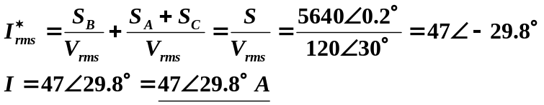

(b) pf = cos(0.2˚) ≈ 1.0 lagging.

